Modern Language Association (MLA): professional organization for students and scholars of language and literature.

Overview

The MLA sets guidelines for how to cite your research in English papers. Recently, they have updated their rules around how to cite websites. (MLA Eighth Edition). This is really important information for you because any time you refer to information in a website in your writing, either directly or indirectly, you have an ethical obligation to cite (list) the source from you which found your info.
Previously, students and researchers creating an MLA website citation were not required to include the URL. When creating an MLA 8 citation for a website, however, it is recommended that you include the URL unless your teacher instructs you otherwise. Even though web pages and URLs can be taken down or changed, it is still possible to learn about the source from the information seen in the URL.
Updates to Guidelines for Citing a Website
1. When including URLs in a citation, http:// and https:// should be omitted from the website’s address. Additionally, if you are creating a citation that will be read on a digital device, it is helpful to make the URL clickable so that readers can directly access the source themselves.
2. If the website’s publisher includes a permalink or DOI (Digital Object Identifier), these are preferable as they are not changeable in the same manner as URLs. Whether you include a URL, permalink, or DOI, this information should be included in the location portion of your citation.
3. Another change with the eighth edition that impacts how to cite a website in MLA is the removal of the date the website was accessed. While you may still find it useful to include this information or your teacher may request it, it is no longer a mandatory piece of your citation. Should you choose to add this optional information, you may list it after the URL in the following manner:
Accessed Day Month Year
For an overview of additional formatting changes in the eighth edition, including resources to help with writing an MLA annotated bibliography, look at the guidelines below:

A) Citing Websites with One Author
To make an MLA 8 citation for a website, you will need the following pieces of information:
The author’s name
The title of the article or page
The title of the website
The name of the publisher (Note: Only include the name of the publisher when it differs from the name of the website.)
The date the page or site was published (if available)
The URL

This is the format for your works cited:
- Place the author’s name in reverse order, the last name first, followed by a comma, and then the first name followed by a period.
- The title of the web page or article is placed in quotation marks, with a period before the end quotation.
- The title of the website is written in italics followed by a comma. If the name of the publisher differs from the name of the website, include it after the title.
- Immediately following the publisher is the date that the page or article was published, or posted.
- Finally, end with the URL, permalink, or DOI.
Like this:
Author’s Last name, First name. “Title of the Article or Individual Page.” Title of the Website, Name of the Publisher, Date of Publication in Day Month Year format, URL.
Example
McNary, Dave. “Keanu Reeves, Alex Winter Returning for ‘Bill and Ted Face the Music.’” Variety, Penske Media Corporation, 8 May 2018, variety.com/2018/film/news/bill-and-ted-3-keanu-reeves-alex-winter-1202802946/.
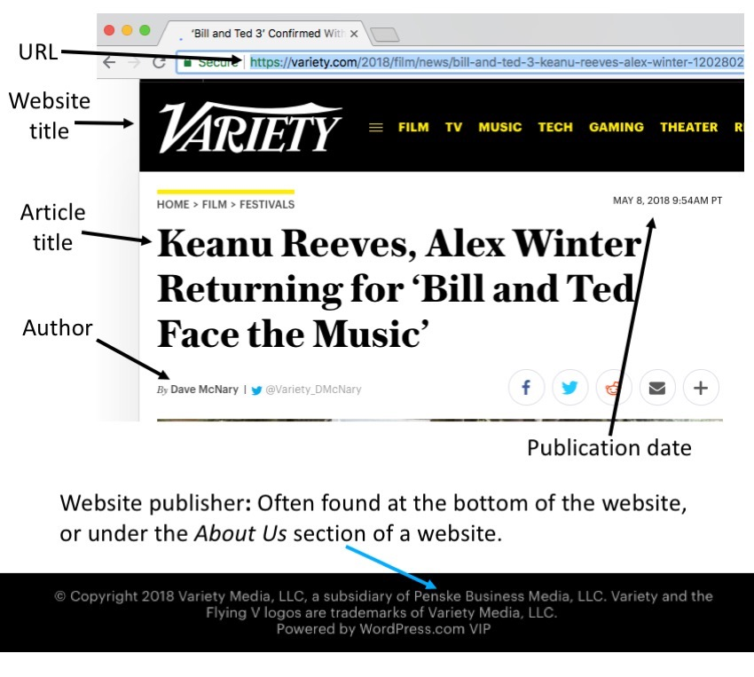
This is the format for your in-text citation:
The in-text citation for a website with an author is reflected as the author’s last name in parentheses, followed by a period. Unless the website includes numbered paragraphs or sections, you should not include any additional information. For the website used in the example above, the in-text citation would be written as follows:
(McNary).
B) Citing a Website with Two Authors:
Your citation should place the authors’ names in the same order as the source. The first name should be formatted in reverse order as was done for a single author. The second name, however, is written as First Name Last Name and is followed by a period, as demonstrated in the example below:
Like this:
Last name, First name of Author 1, and First Name Last Name of Author 2. “Title of Web Page.” Title of Website, Publisher, Date Published in Day Month Year format, URL.
Example:
Wadhwa, Vivek, and Alex Salkever. “How Can We Make Technology Healthier for Humans?” Wired, Condé Nast, 26 June 2018, www.wired.com/story/healther-technology-for-humans/.
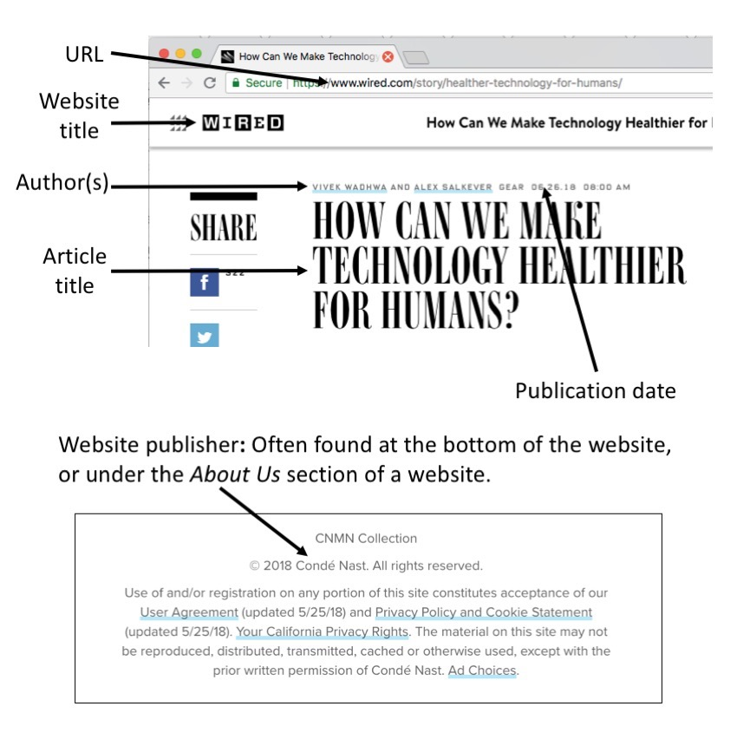
This is the format for your in-text citation for a website with two authors
Include both authors’ last names, in the order in which they are listed in the source and your works cited:
(Wadhwa and Salkever).
C) Citing a Website with Three or More Authors:
You should place the authors’ names in the same order as the source. The first name is listed in reverse order and is followed by a comma and et al. Et al is the abbreviation for et alia, a gender-neutral Latin phrase meaning “and others.”
First listed author’s Last name, First name, et al. “Title of Web Page.” Title of Website, Publisher, Date published in Day Month Year format, URL.
The in-text citation for a website with three or more authors should contain only the first author’s last name, followed by et al:
(Last Name 1 et al.).

D) Citing a Website with No Author
Sometimes, websites do not state who wrote the information on the page. When no author is listed, you may omit the author information from the MLA citation for the website and begin, instead, with the title.
How to cite a website with no author in MLA 8:
“Title of Web Page.” Title of Website, Publisher, Date published in Day Month Year format, URL.
“One Health and Disease: Tick-Borne.” National Park Service, U.S. Department of the Interior, https://www.nps.gov/articles/one-health-disease-ticks-borne.htm.
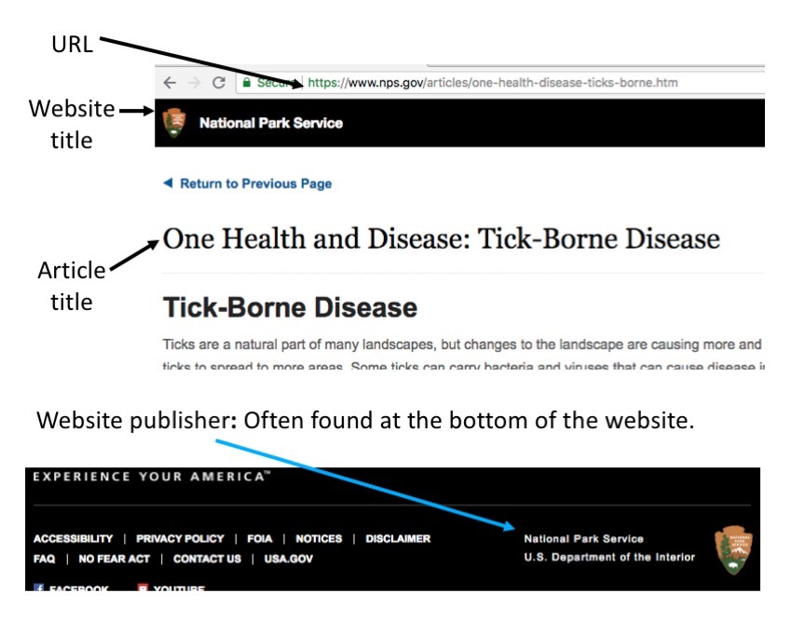
The in-text citation for a website without an author is noted with the first word or words in the title in parentheses, followed by a period. Unless the website includes numbered paragraphs or sections, you should not include any additional information. For the website used in the example above, the in-text citation would be written as:
(One Health and Disease).

Source: http://www.easybib.com/guides/citation-guides/mla-format/how-to-cite-a-website-mla/

