What I Wish to Tell

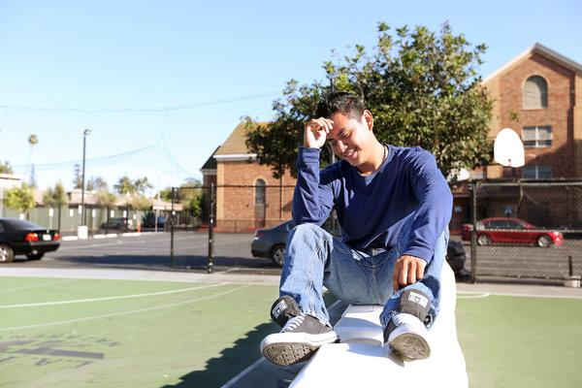
Jose, 16, Youth Radio (Jose is undocumented. He is using his first name only to protect his privacy. His essay has been translated from Spanish.)
Los Angeles
Salvadoran
I remember the first day I learned what American racism means. My friend and I were walking home from school and we walked by a white couple. They looked at us and started talking to each other in hushed tones. We couldn’t understand everything they said, but we caught some bad stuff about Latinos and immigration, and we knew they were talking about us. We just kept on walking. It’s not worth getting into a back-and-forth. It’s better to just be quiet.
They don’t know the stuff that we had to go through back home.
I wish I could tell them about my life in El Salvador. Back there, things are really tough with gangs. There was a time when I was walking to the store and a couple of gang members stopped me and asked, “What do you bang?” I don’t, I told them. “So what are you doing in this area?” they replied. It was clearly a threat.
I would tell them how hard it was to say goodbye to my friends and family. I wasn’t going to go to same school anymore. I wasn’t going to have the same friends. I wasn’t going to live with the family I grew up with all my life. I asked God to help me, asked him to guide me, to bless me and keep me safe during this journey.
I would tell them about the day I left home, how I woke up at 3 a.m. nervous and sad. I didn’t know what to expect. I envisioned the United States as this big city where things were so close and everything was accessible, like hospitals and businesses. When I finally got here, everything felt strange to me, from the language to the streets. Everything.
I would tell them about how hard I’ve worked for people to accept me. At school, I’ve tried to be friendly, but there have been times when people have said things to me because I speak Spanish. You know, racist people who say, “This is America. You should speak English.” I don’t care what people say. At the end of the day, they don’t pay my bills.
Back in El Salvador, I didn’t really know what racism was. I knew it had something to do with discriminating against someone. After being in the United States for a while, I learned the meaning and impact of that word. It’s sad that people can be hurtful. They just don’t understand. It’s hard to be an immigrant kid. Our backgrounds haven’t been easy, and we just want something better.
•What happened to Jose and what was his response?
•What is your personal reaction to this story?
•How did Jose and his friend know the white couple was talking about them?
•What were some of the hardships Jose faced in his journey, and why did he wish the white couple knew that?
•Why do you think Jose said he didn’t understand discrimination until he came to the United States?

