A Lesson from Kindergarten

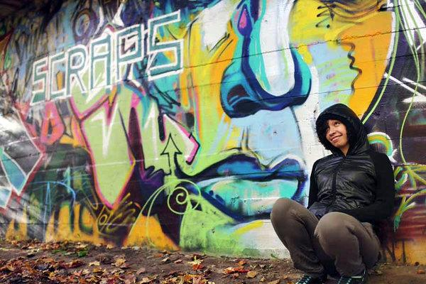
Maya James, 19, Youth Radio
Traverse City, Mich.
Mixed Race (Black/White)
Shortly after enrolling in kindergarten, one of my classmates threw the N-word at me in a small scuffle. I cannot remember what the little boy was so upset about — it was probably something elementary school students usually get upset about. Maybe I was hogging the markers; maybe I cut in line, or vice versa.
It was the first time I had ever heard that word. I didn’t know how to react. I had many questions. Should I be upset? Could I call the white student the N-word, too? Who invented this word? Do adults use the word?
Before that moment, I had no idea what race was or what class meant. Now I had to grow up.
My teachers tried to intervene — yanking the little boy’s arm and demanding he look in my eyes and “see the pain she feels!” They forced him to stay in and write apology letters during recess in their words, not his. “I should have thought before saying black people are bad,” says one note I’ve kept all these years, “To me, you are a good friend.”
But the letters didn’t stop the name-calling or the rock throwing at recess, at the bus stop or after school.
Back then I had a lot of loud temper tantrums. I was not a picnic for my parents. I cried a lot, I was irritable. That’s when my father — who grew up in Longview, Tex., at the height of Jim Crow politics — started talking to me about race. After my teachers told him about the incident, he had no choice; he had to teach his 5-year-old daughter the tragic story of African genocide and white supremacy that was the American slave trade.
My dad’s struggle and the struggle of his parents were now rubbing off on me at such a young age. No longer a little girl in the suburbs, but a descendant of people considered cattle. No reparations.
I remember thinking: This is unfair! What did I do to be born black?
Traverse City, Mich., is 94 percent white. So it’s no wonder I felt alone growing up as a half-black, half-white little kid.
I am biracial, but in the United States, more often than not, I am always going to be labeled a person of color. I constantly have to choose between one side of my culture and the other — always seeking a greater identity. I feel like a puzzle piece that got lost, always trying to find some way to fit.

- What happened to Maya and what was her response?
•What is your personal reaction to this story?
•Why do you think Maya’s father starting talking to her about race and racism when she was 5 years old?

- Why does Maya feel she has to choose one race over the other in how she defines herself?
•How do you think this affected Maya differently as a biracial person than it might someone who is one race or with a different racial identity?

